Instructor: Dr. Jie Shen
Release date: March 24, 2021
Due date: April 14, 2021

Student Name: Demetrius Johnson
*Special note: see my lab uploads of the .CPP and .EXE files for ease of access and testing any of the programs for any question.

Table of Contents
Question 1 – Linked List Stack ADT (30 pts.) 3
Source code (USED C++ COMPILER on Microsoft Windows 10) 3
Test data and expected results 3
Question 2 -Linked List Queue ADT (30 pts.) 5
Source code (USED C++ COMPILER on Microsoft Windows 10) 5
Test data and expected results 5
Submission 7
Provide an MS word document or a pdf file with the following information: 7

Question 1 – Linked List Stack ADT (30 pts.)

Source code (USED C++ COMPILER on Microsoft Windows 10)
***SEE: CIS-200_Assg4-Q1.cpp, stackADT.h, and stackADT.cpp uploaded in canvas.

Test data and expected results

Test Table:
Test # | Valid / Invalid Data | Description of test | Input Value | Expected Output | Actual Output | Test Pass / Fail
1 | valid | Testing integer stack ADTs: creation, push, pop, size, make empty, is empty, is full, and print functions, copy constructor with deep copy | Push 11, 22, pop 22, push 33; second stack: push 44, 55, 66 | See screenshot; cout for first stack should be 33, 11, since 22 was popped, 33 was the last item pushed; second stack should be 66, 55, 44, 33, 11 since 44, 55, and 66 were pushed in that order | See screenshot | pass
2 | valid | Testing float stack ADTs: creation, push, pop, size, make empty, is empty, is full, and print functions, copy constructor with deep copy | Push 7.1, 2.3, 2.1, pop 2.1, | Cout should be 2.3, 7.1 since 2.1 was pushed last and then popped | See screenshot | pass

TEST 1:
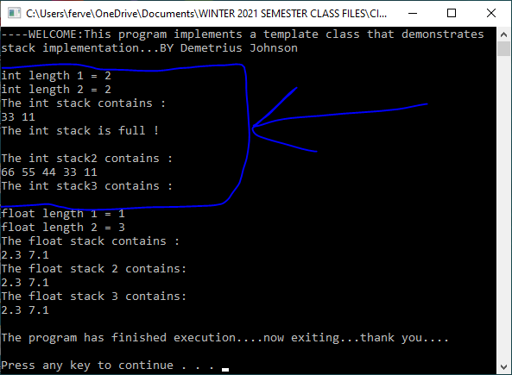
*note above, the int stack3 contains nothing so output is void; stack3 output is a result of making intStack empty using the makeEmpty function; also int stack is full after output of 33 and 11 since 44, 55, and 66 was added to the stack before isFull was called.
TEST 2:
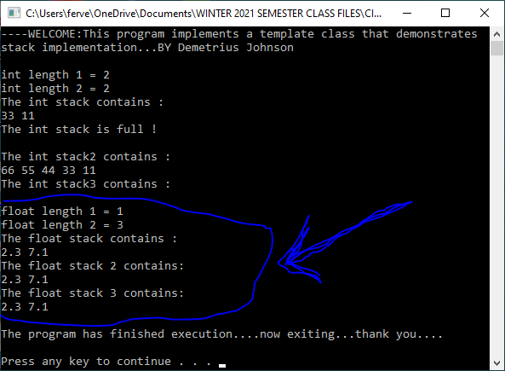

Question 2 -Linked List Queue ADT (30 pts.)

Source code (USED C++ COMPILER on Microsoft Windows 10)
***SEE: CIS-200_Assg4-Q2.cpp, queueADT.h, and queueADT.cpp uploaded in canvas.

Test data and expected results

Test Table:
Test # | Valid / Invalid Data | Description of test | Input Value | Expected Output | Actual Output | Test Pass / Fail
1 | valid | Testing integer queue ADTs: creation, enqueue, dequeue, size, make empty, is empty, is full, and print functions, copy constructor with deep copy | Enqueue 10, 20, 30, 40, dequeue 10 | See screenshot; cout should be 20, 30, 40, since 10 was dequeued from front | See screenshot | pass
2 | valid | Testing float queue ADTs: creation, enqueue, dequeue, size, make empty, is empty, is full, and print functions, copy constructor with deep copy | Enqueue 7.1, 2.3, 3.1, dequeue 7.1 | See screenshot; output of queue should just be 2.3, 3.1, since 7.1 was dequeued from the front | See screenshot | pass

TEST 1:
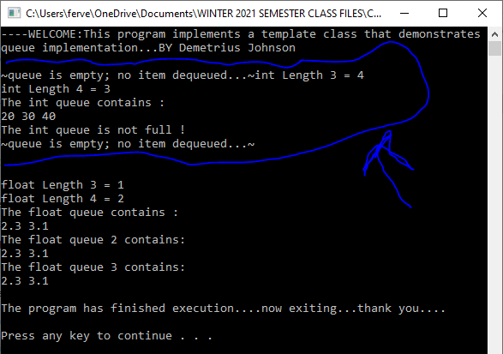
TEST 2:
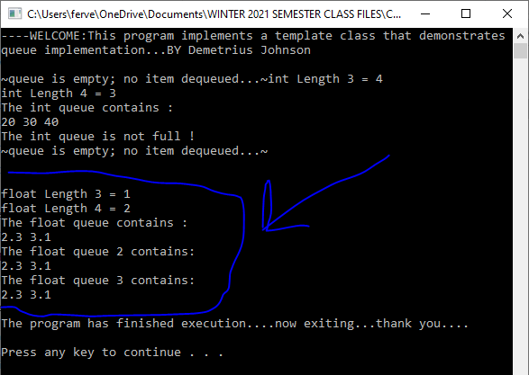

Submission

Provide an MS word document or a pdf file with the following information:
- Cover page with lab number and title, your name, date
- Test data and expected results
- Running log/output (screen shots should be provided)
- Insert the source code and screenshots into the word document
- You should submit your work through Canvas site for cis 200 lab.
- The filename of the word document should follow the convention: FirstName_LastName_Cis200Lab3.doc or pdf.

